Name: Class:

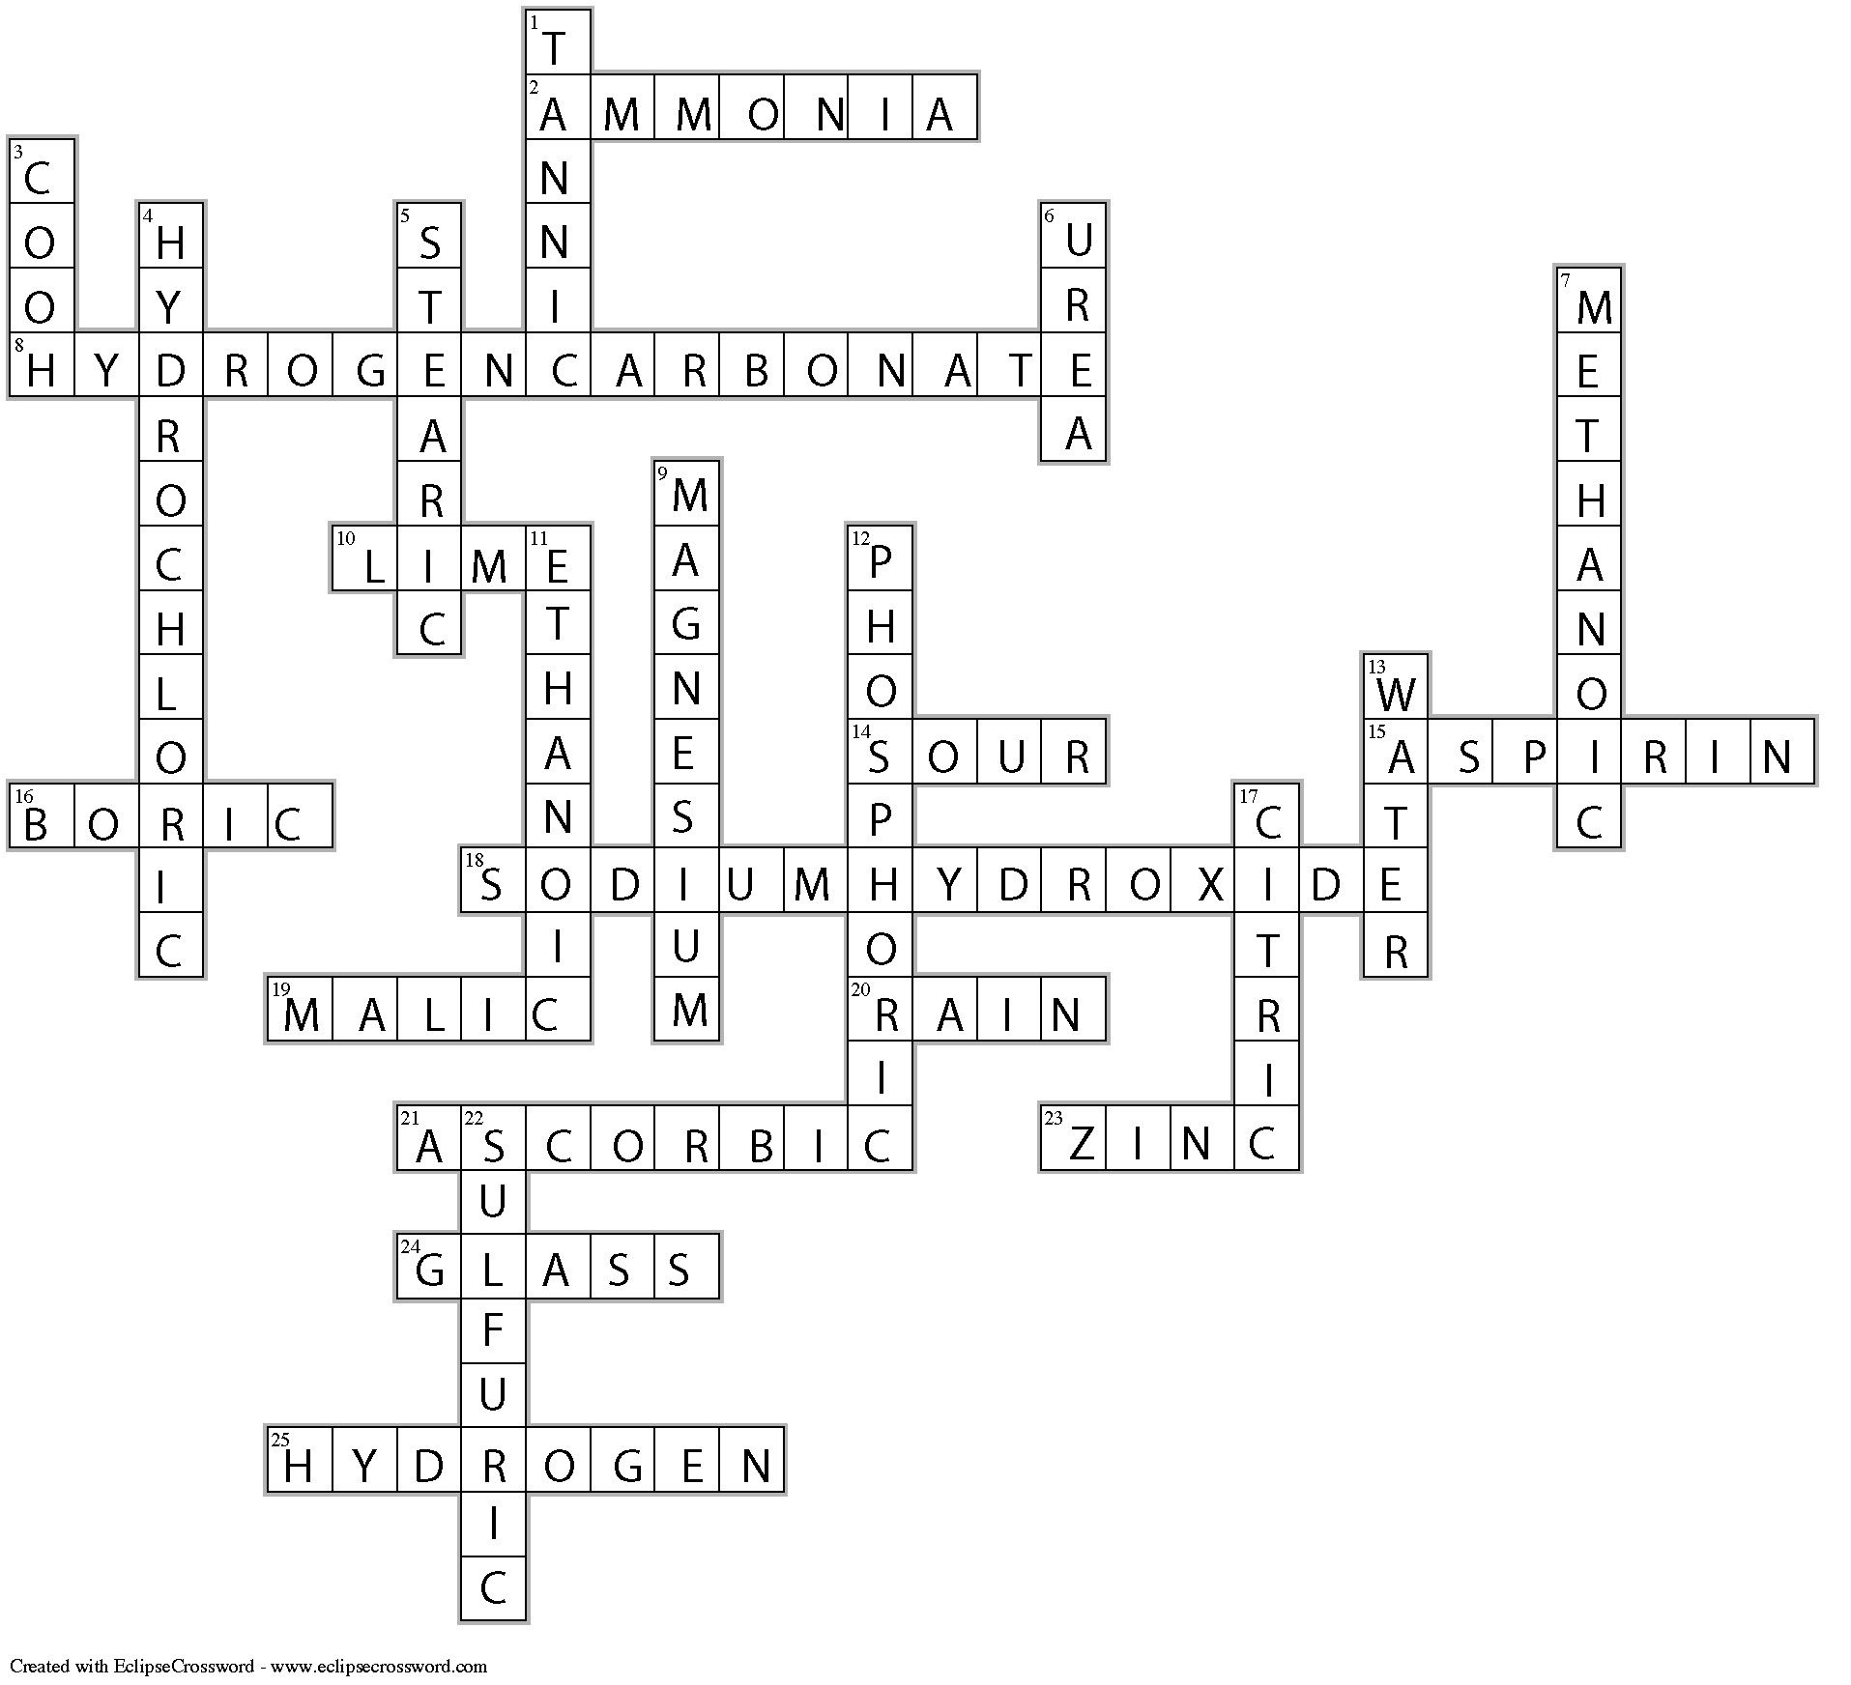

Across
2. AMMONIA—Many window cleaners contain this basic substance.
8. HYDROGENCARBONATE—The sodium salt of this ion is baking soda.
10. LIME—A common name for a hydroxide used to neutralise soil acidity.
14. SOUR—The taste of an acid.
15. ASPIRIN—The analgesic chemically known as acetyl salicylic.
16. BORIC—______ acid is a mild antiseptic used in ointments for dressing wounds.
18. SODIUMHYDROXIDE—A caustic chemical used in drain cleaners. (6, 9)
19. MALIC—______ acid is found in grapes and apples, particularly unripe ones.
20. RAIN—Carbonic acid is found naturally in this watery substance.
21. ASCORBIC—_______ acid is Vitamin C.
23. ZINC—Many watch batteries have this hydroxide as a reactant.
24. GLASS—Hydrofluoric acid is used to etch this substance.
25. HYDROGEN—Produced when hydrochloric acid reacts with iron.

Down
1. TANNIC—______ acid is found in wine and tea.
3. COOH—The chemical formula for the carboxylic acid functional group.
4. HYDROCHLORIC—______ acid is the main component of concrete cleaner.
5. STEARIC—A fatty acid with molecular formula of C₁₈H₃₆O₂, found widely in solid fats.
6. UREA—Human urine contains this basic substance.
7. METHANOIC—_______ acid is the systematic name for the acid present in bee stings.
9. MAGNESIUM—One of the hydroxides commonly used in antacid preparations.
11. ETHANOIC—______ acid is the systematic name for the acid in vinegar.
12. PHOSPHORIC—______ acid is an active ingredient in Coca-Cola.
13. WATER—One of the products of the reaction between an acid and a metal hydroxide.
17. CITRIC—Lemons and oranges contain ______ acid.
22. SULFURIC—______ acid is found in most car batteries.

